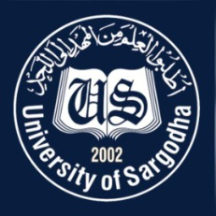  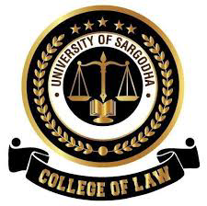 | Faculty Positions on Visiting Basis
College of Law
University of Sargodha
Applications for the following positions are invited from Pakistani nationals for Fall & Spring semester 2022-23
Teaching Faculty

Sr.# | Positions | Subject | No. of Posts | Nature of Post | Eligibility Criteria
1 | Visiting Professor / Assistant Professor | Post Graduate Diploma in Income Tax Laws | 04 | Visiting Faculty  (Open merit, for Fall & Spring semester 2022-23) | Experience:-  - 10Years or more Professional Experience as income tax officer in Land Revenue office, FBR with/without graduation in Law or Advocate High Court with 10 Years active practice in taxation, preferably office bearers from Tax Bar as President Tax Bar.
NOTE |  |  |  | General Information
- As per university policy, the College of Law reserves the right not to consider any application or fill any post without giving any reason.
- Candidates are required to submit complete latest C.V, License of High Court, two latest Passport Size Pictures and attested copies of all testimonial documents along with duly filled application form in the Admin Office of College of Law, University of Sargodha.
- Prescribed application form may be downloaded from university website
(https://www .uos.edu .pk/adminForms)
- Applications complete in all respects should reach the College of Law on or before 20-10-2022 (Thursday).
- Only short listed candidates will be called for interview. List of short-listed candidates will be displayed on 21-10-2022 (Friday).
- Interview of the short-listed candidates will be conducted on 21-10-2022 (Friday) at11:00A.M in the office of Incharge Principal, College of Law, University of Sargodha.
- The applicants having provisional transcript will not be eligible for the visiting faculty
- Applications received after due date will not be entertained.
- Candidates with relevant experience will be preferred.
- Seats can be increased or decreased according to the availability of Credit Hours.
- Applications should be addressed to Incharge Principal, College of Law, University of Sargodha.
- Online applications will not be accepted.

Incharge Principal
College of Law,
University of Sargodha

